COMP-3710

Zikun Xu

Feb.12rd 2019

Guide for user:

I build my app on Android 10.0. So, user need Android 10.0 or newer device to run this App.

Step 1

Open my app

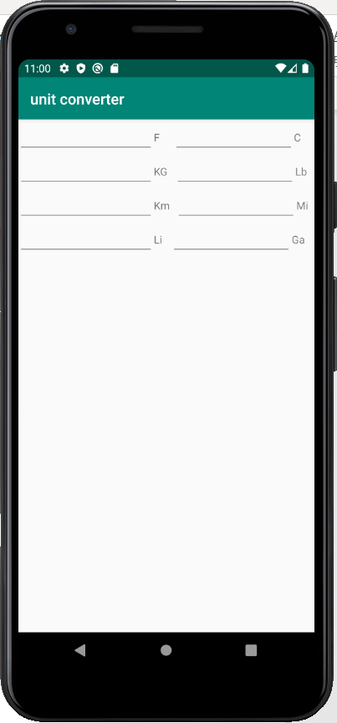

Step 2

Enter the number you want to convert, the data will appear automatically

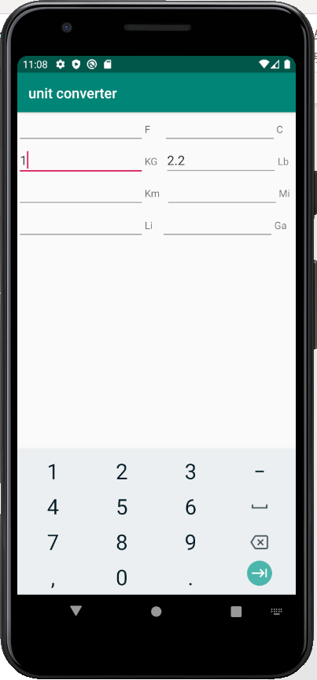

Step3

If you want to enter multiple data in one time, the data still appear automatically

